KIM WELBORN

CostumeKim@gmail.com / (321) 482-1910

PROFESSIONAL SUMMARY

Experienced costume and production designer, costumer, and shop manager. Excellent ability to conceive and implement timely, cost-effective costume plots clearly conveying director’s vision. Expert in fashion history and period construction.

SKILLS

- Outstanding ability to adapt and alter existing costumes for all body types
- Able to develop and work effectively within budget
- Excellent understanding of functional costuming for dancers, singers, and specialty performers.
- Expert patternmaker, draper, cutter, milliner, and seamstress
- Artisan in leather, EVA foam, thermoplastics, and other non-traditional materials
- Strong collaborator and communicator (English, functional French, some Spanish
- Extremely flexible and adept under pressure.
- Effective shop manager, shopper, project manager, mentor

COSTUME DESIGN

Musicals: A Little Night Music (Opera in the Ozarks); The Best Christmas Pageant Ever

(Cumberland County Playhouse); Evita, Spamalot, South Pacific, The Producers, Guys

and Dolls, Tommy, Gypsy, Paint Your Wagon, Hello Dolly, The Wizard of Oz

(Fractured), (Surfside); Babes in Toyland (Henegar Center); Charlotte’s Web, The

Jungle Book, Willie Wonka (Children’s Theatre, various companies)
Opera: Tales of Hoffman, Hansel & Gretel (multiple productions), Amahl & the Night Visitors (multiple productions), Marriage of Figaro, All is Calm (Opera Orlando); Pagliacci/Pulcinella (Opera Orlando, Savannah Opera) La Bohème, (Opera Orlando, Opera in the Ozarks); Don Pasquale (Opera Orlando, Vero Beach Opera); Abduction from the Seraglio (Opera Orlando, Opera in the Ozarks); La Rondine, Cosi Fan Tutte, Pinocchio, Little Women, Lucia De Lammermoor, Cendrillon, Monkey See, Monkey Do, The Magic Flute, Elisir D’Amore, The Tender Land, Orpheus in the Underworld (Opera in the Ozarks); Die Fledermaus (First Coast Opera); Brundibar, Noye’s Fludde (Opera Orlando Youth Company); My Dearest Friend (World Premiere for National Park Service Centennial, Boston); Pirates of Penzance (International Opera Center); Birthday Clown (World Premiere, Savannah Opera); Dido and Aeneas (University of Northern Iowa Guest Designer)
Plays: MacBeth, Where the Wild Things Are (PowderHorn Theatre); Diary of Anne Frank, Miracle on 34th Street, Extremities, On Golden Pond, The Rainmaker, The Ritz, Noises Off, Steel Magnolias, The 39 Steps, The Game’s Afoot, Alice in Wonderland, Blithe Spirit (Surfside)
Outdoor Drama: Horn in the West (Daniel Boone Theatre) 3 Seasons
Dance: Alice in Wonderland, Peter & the Wolf, Piccola (Rockledge Children’s Theatre); Tyber River Dancers (Renaissance Touring Company); Flamenco, Hungarian and other folk and ethnic styles.

SPECIAL DESIGN PROJECTS:
- Historically accurate clothing for live and film reenactments including Florida’s Quincentennial, the founding of St. Augustine, British Night Watch, Ancient American and MENA events
- Constitution Bicentennial Ball; History Week Fashion Shows; Porcher House Christmas; Pirates exhibit, Brevard Museum
- Grand Mask Event, Palm Beach Fashion Week
- Fantasy Fest, Key West
- Madrigal Dinners, multiple producers
- Opening Events, Omni International Mall, Miami
- Performance Gowns, Wendy Bryn Harmer (Metropolitan Opera)

EDUCATION/CERTIFICATIONS ETC.

IATSE Local 829; OSHA 10 Certificate

BA Liberal Studies, CUNY School of Professional Studies, New York, NY 2021; 4.0 GPA;

ACE Mentor Scholar; CUNY Cultural Corps; Arts Administration Intern @ New York Classical Theatre

MOMA Fashion as Design Certificate

AFA Fashion Studies, International Fine Arts College, Miami, FL Emphasis on design; 4.0 GPA

Student Government President; Saks Fifth Avenue Design Competition Winner

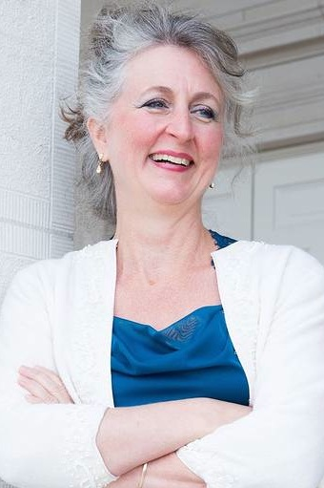
Independent Studies, Bangkok, Thailand; Pattern drafting, draping, tailoring, fitting, and cutting

